**EVENT MANAGER**

**#4WEEK 4APP**

1st APP

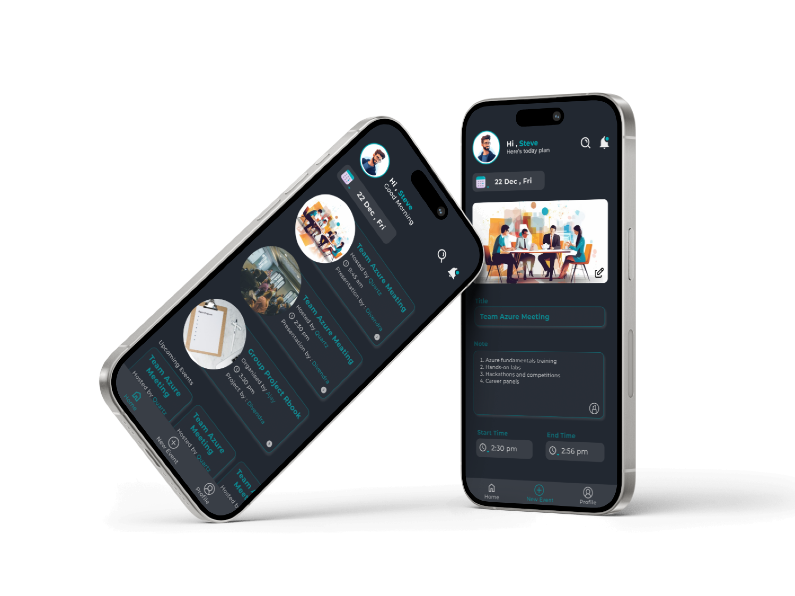

URL

<https://www.figma.com/proto/msAGKt70D4SfqdqAA5mdYw/gyanendra-project?page-id=0%3A1&type=design&node-id=0-3&viewport=364%2C227%2C0.1&t=79PZgNZSznI3KXrJ-1&scaling=scale-down&starting-point-node-id=29%3A313&mode=design>

When navigating pages, two types of animations are employed: one for gradual loading when the app requires time, and another for instant loading.

To access different animations, you'll find a layout icon positioned at the top left. Click on the desired heading to view the animation.

The entire app has been prototyped, allowing you to click on icons for a more comprehensive understanding of the application.(except back icon)

If you do not observe any animations initially, kindly click the "R" button (for laptop/PC) or the reset button (for mobile).

If you observe any delay in animation, it is likely caused by a slow internet speed